**Practical No-9**

**Design and Develop MongoDB Queries using CRUD operations. (Use CRUD operations,SAVE method, logical operators)**

**view all databases:-**

show dbs



----------------------

**create new database:-**

use College

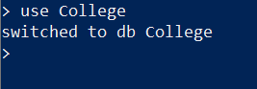

---------------------

**delete database:-**

db.dropDatabase()



------------------------------

**create new database:-**

use College



-------------------------------

**veiw collections of selected db:-**

show collections

-------------------------------

**create new collection**:-

db.createCollections('Student’)



-------------------------------

**delete collections:-**

db.Student.drop()



-------------------------------

Show collections of Db:-

show collections



-------------------------------

**insert record in collection:-**

db.Student.insert({

'name':'Sanket',

'age':20,

'Lang': 'English',

'marks':90

})

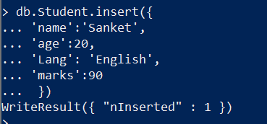

db.Student.insert({

'name':'abhi',

'age':20,

'Lang': 'Eng',

'marks':70

})

-------------------------------

db.Student.insert({

'name':'Mayur',

'age':19,

'Lang': 'Hindi',

'marks':80

})

-------------------------------

db.Student.insert({

'name':'hariom',

'age':19,

'Lang': 'Hindi',

'marks':80

})

-------------------------------

**insert multiple records:-**

db.Student.insertMany([

{'name':'mahesh',age:22,'Lang': 'marathi','marks':99},

{'name':'ganesh',age:19,'Lang':'hindi','marks':80},

{'name':'santosh',age:14,'Lang':'marathi','marks':60}])

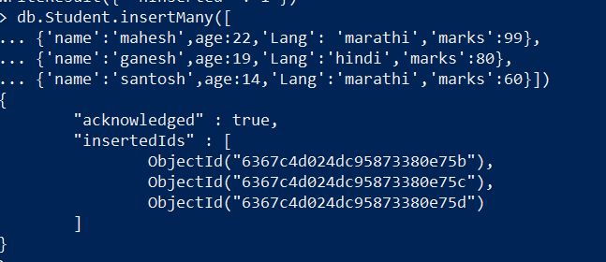

-----------------------------------------------------------

**see inserted records:-**

db.Student.find()

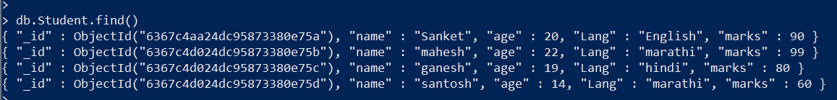

-------------------------------

**see inserted records in pretty format:-**

db.Student.find().pretty()

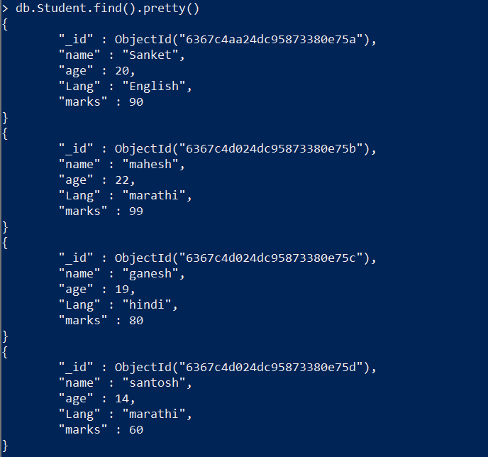

-------------------------------

**find records:-**

db.Student.find({marks:99})



-----------------------------

**find one row only:-**

db.Student.findOne({name:'Sanket'})

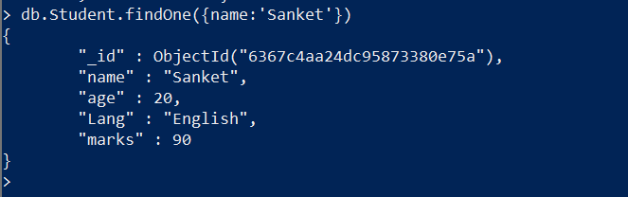

------------------------

**set limit to output:-**

db.Student.find({marks:80}).pretty().limit(2)

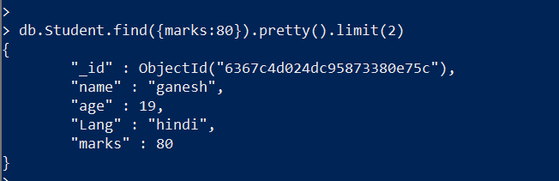

----------------------

**update a row:-**

db.Student.update({'name':'mahesh'},

{

'name':'hariom',

'age':19

})

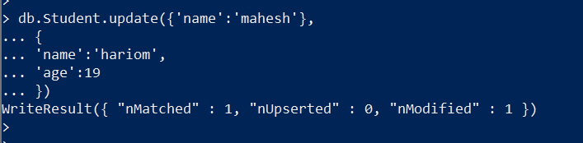

---------------------

**delete row :-**

db.Student.remove({'name':'hariom'})



--------------------